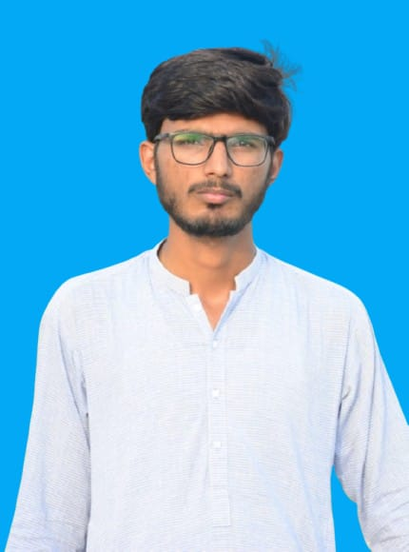

**MUHAMMAD MUZAMIL**

**PERSONAL INFORMATION**

**EDUCATION**

I am motivated and enthusiastic Computer Science student in the 4th semester, eager to apply theoretical knowledge in real-world projects. Seeking an **Internship** opportunity to contribute to a dynamic team while gaining hands-on experience in software development and problem-solving.

✉️ [malikmuzamil3889@gmail.com](mailto:malikmuzamil3889@gmail.com)

📞 03287362120

🏡 CHAK NO 5 FAIZ TEHSIL MULTAN SADDAR, DISTRICT MULTAN

**CAREER OBJECTIVE**

**LANGUAGES**

* ENGLISH
* URDU

**HOBBIES**

**Languages:** HTML,CSS, Javascript, C++, Kotlin,C#,

**Databases:** MySQL

**Tools & Platforms:** GitHub,

Android Studio, VS Code, Visual Studio

**TECHNICAL SKILLS**

Bachelor of Science in Computer Science

Air University Multan Campus

5th Semester

**Cgpa:** 3.01

**Covered Courses:** Data Structures, DBMS, OOP, Computer Networks, Mobile Computing

* Cricket
* Video Gaming
* Book reading